CS 355 Project 1

1. Overview

This database is intended to keep track of and organize data about space launch attempts and their outcomes, as well as the parties involved in these launches.

Launch attempts involve a launch vehicle which may have payloads, and a launch pad, and occur at a defined date and time, and may result in a successful launch, a delay/scrub, or a more catastrophic failure that destroys the rocket and payload. A launch vehicle is of a particular model, and provided by an organization, and may host multiple payloads to multiple destinations. This vehicle model will have a specific thrust at sea level, mass at launch, and may be in continued operation or defunct. A payload will have an intended destination, which may be an orbit type or extraterrestrial body, and will belong to some organization. Payloads will be launched by one launch vehicle, and may be a success, partial success, or failure independent of the success of any of its launch attempts. Launch pads are operated by an organization, and will be located at some location (often an Air Force Base) with an address, which bay be host to several launch pads. An organization may own/operate launch vehicles, payloads, or launch pads, and will have a start and end date, along with a location for its headquarters.

This can be summarized as following: An organization may operate launch vehicles, payloads, and launch pads. A launch vehicle is of a particular type, and hosts multiple payloads. Both a launch pad and an organization headquarters has a location. A launch attempt involves a vehicle carrying payloads, and a launch pad.

Entity Relationship Diagram:

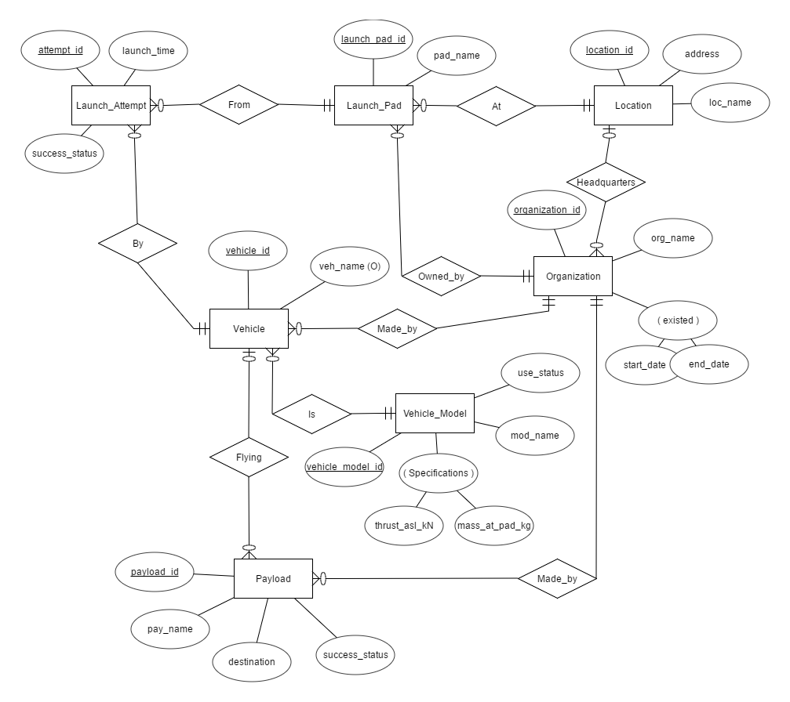

Relational Schema:

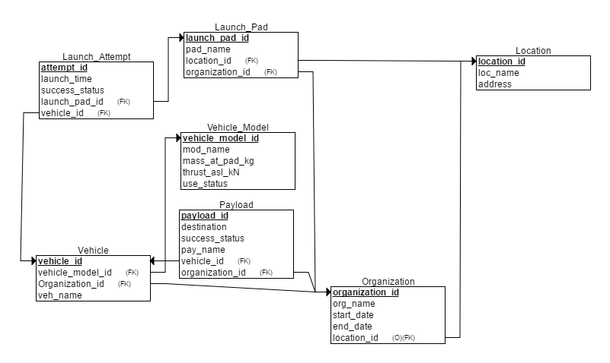

Functional Dependency Diagram:

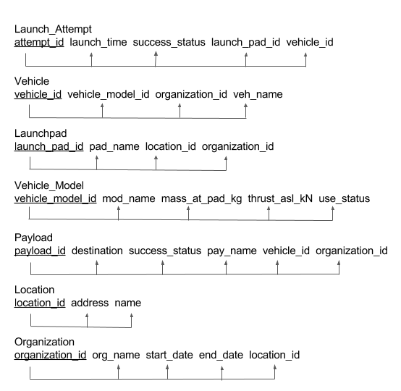

1. Description of tables, attributes, and keys

Table 1: location

Purpose: Stores the addresses and names of locations.

Attributes: The name of the location (for instance, Vandenberg AFB), the address of that location. The address should be unique.

Keys: Each location is assigned a unique location ID, which is its primary key.

MySQL: create table location(

location_id int auto_increment primary key,

loc_name varchar(127),

address varchar(255) unique);

Table 2: organization

Purpose: Stores information on organizations

Attributes:

Keys:

MySQL:

Table 3: launch_pad

Purpose:

Attributes:

Keys:

MySQL:

Table 4: vehicle_model

Purpose:

Attributes:

Keys:

MySQL:

Table 5: vehicle

Purpose:

Attributes:

Keys:

MySQL:

Table 6: launch_attempt

Purpose: Stores information on launch attempts, whether they were scrubbed (cancelled) or not.

Attributes: planned time of launch, whether it succeeded or failed (or scrubbed), the ID of the pad it took place on, and the ID of the particular vehicle involved.

Keys: Each launch attempt is assigned a unique launch attempt ID, which is its primary key. The pad ID and the vehicle ID should be referred to the launch_pad and vehicle tables respectively prior to the entry.

MySQL: create table launch_attempt(

launch_attempt_id int auto_increment primary key,

launch_time datetime,

success_status enum('success', 'scrub', 'failure'),

launch_pad_id int,

vehicle_id int,

foreign key (launch_pad_id) references launch_pad(launch_pad_id) on delete cascade,

foreign key (vehicle_id) references vehicle(vehicle_id) on delete cascade);

Table 6: payload

Purpose:

Attributes:

Keys:

MySQL: